SIMATS ENGINEERING (SAVEETHA SCHOOL OF ENGINEERING)
Department of Computer Science and Engineering
CO3 ASSESSMENT TOOL 1 – Git & Docker Technical Assignment

Course Code: | CSA10 / CSA1007 | Course Title: | Software Engineering
CO Assessed: | CO3 | Assessment: | Intelligent Nuclear Power Plant Monitoring Platform
Weightage: | 20% | Total Marks: | 25
CO3 Statement: | Build full-stack applications with an emphasis on containerization, version control, and collaborative development
Student Name: | V.Naga Revanth | Reg. No.: | 192411128
Date: |  | Duration: | 60 minutes

Code of Conduct
I ________V.Naga Revath_______/192411128___________ (Name / Reg No) certify that this submission is my original work and that I have adhered to the guidelines specified for this assessment. I understand that any violation of academic integrity rules will result in disciplinary action.
Signature of the Student: _________________________
Annexure A – Intelligent Nuclear Power Plant Monitoring Platform

1. Introduction
The Intelligent Nuclear Power Plant Monitoring Platform is a safety-oriented software system designed to continuously monitor reactor conditions, equipment health, radiation levels, and operational parameters. The system uses IoT sensors, real-time data processing, AI-based anomaly sdetection, predictive analytics, secure databases, and dashboards to support plant operators and safety personnel.
The system is intended to provide decision support and monitoring. It does not directly control safety-critical reactor operations. Any operational action remains under authorized plant procedures and human supervision.
1.1 System Objectives
- Monitor reactor conditions continuously.
- Detect abnormal operating conditions.
- Predict possible equipment failures.
- Monitor radiation levels.
- Generate immediate alerts for abnormal conditions.
- Support emergency response activities.
- Generate compliance and operational reports.
- Reduce unplanned equipment downtime.
- Improve decision support for plant personnel.
- Maintain secure and reliable operational records.

2. System Requirement Analysis
2.1 Functional Requirements
The proposed system shall provide the following functions:
- User authentication and authorization.
- Role-based dashboard access.
- Real-time sensor data collection.
- Reactor temperature monitoring.
- Pressure monitoring.
- Coolant and flow monitoring.
- Equipment health monitoring.
- Radiation-level monitoring.
- Historical data storage.
- Real-time anomaly detection.
- Predictive maintenance analysis.
- Alert and notification management.
- Emergency incident logging.
- Maintenance scheduling.
- Compliance report generation.
- Historical trend analysis.
- Audit-log management.
- Backup and recovery.
2.2 Non-Functional Requirements
Scalability
The system should support additional sensors, equipment, users, and potentially multiple plant units without major architectural changes.
Reliability
The monitoring platform should continue operating correctly despite individual component or sensor failures.
Availability
The platform should be designed for continuous operation because monitoring activities are required 24×7.
Performance
Sensor information and critical alerts should be processed with low latency. Dashboard data should be refreshed rapidly enough for operational monitoring.
Security
Only authorized personnel should access plant information. Authentication, authorization, encryption, network segmentation, audit logging, and secure APIs should be implemented.
Maintainability
The software should be modular so that monitoring, analytics, reporting, authentication, and alert services can be updated independently.
Usability
Operators should be able to understand the status of the plant quickly through dashboards, status indicators, trends, and prioritized alerts.
Data Integrity
Sensor readings, alerts, maintenance records, and compliance information must be protected against accidental or unauthorized modification.

3. Quality Attributes Influencing Architecture
Quality Attribute | Architectural Requirement
Scalability | Independently scalable processing and analytics services
Security | Authentication, RBAC, encryption, audit logs and network isolation
Performance | Real-time data pipeline and in-memory processing where appropriate
Reliability | Redundant services, health checks and failure recovery
Availability | Fault-tolerant deployment and backup infrastructure
Maintainability | Modular services and clearly defined APIs
Usability | Web-based monitoring dashboard
Interoperability | REST APIs and standard data interfaces
Data Integrity | Transactional database and controlled access
Observability | Centralized logs, metrics and health monitoring

4. Selection of Software Architecture
Selected Architecture: Hybrid Event-Driven Microservices Architecture
A Hybrid Event-Driven Microservices Architecture is selected for the Intelligent Nuclear Power Plant Monitoring Platform.
The architecture combines:
- Microservices
- Event-driven processing
- Layered application design
- API-based communication
- Centralized data management
- Real-time analytics
4.1 Why This Architecture Is Suitable
A nuclear plant monitoring platform generates continuous streams of sensor data. Different functions such as monitoring, anomaly detection, predictive maintenance, alert management, reporting, and user management have different processing requirements.
A single monolithic application would make the system difficult to scale and maintain. Microservices allow individual functions to be developed and maintained independently.
The event-driven approach is suitable because sensor readings and alerts naturally generate events.
For example:
Sensor Reading
↓
Data Ingestion
↓
Event
↓
Anomaly Detection
↓
Abnormal Condition?
/ \
Yes No
↓ ↓
Alert Store Data
↓
Operator Dashboard

5. Software Architecture Diagram

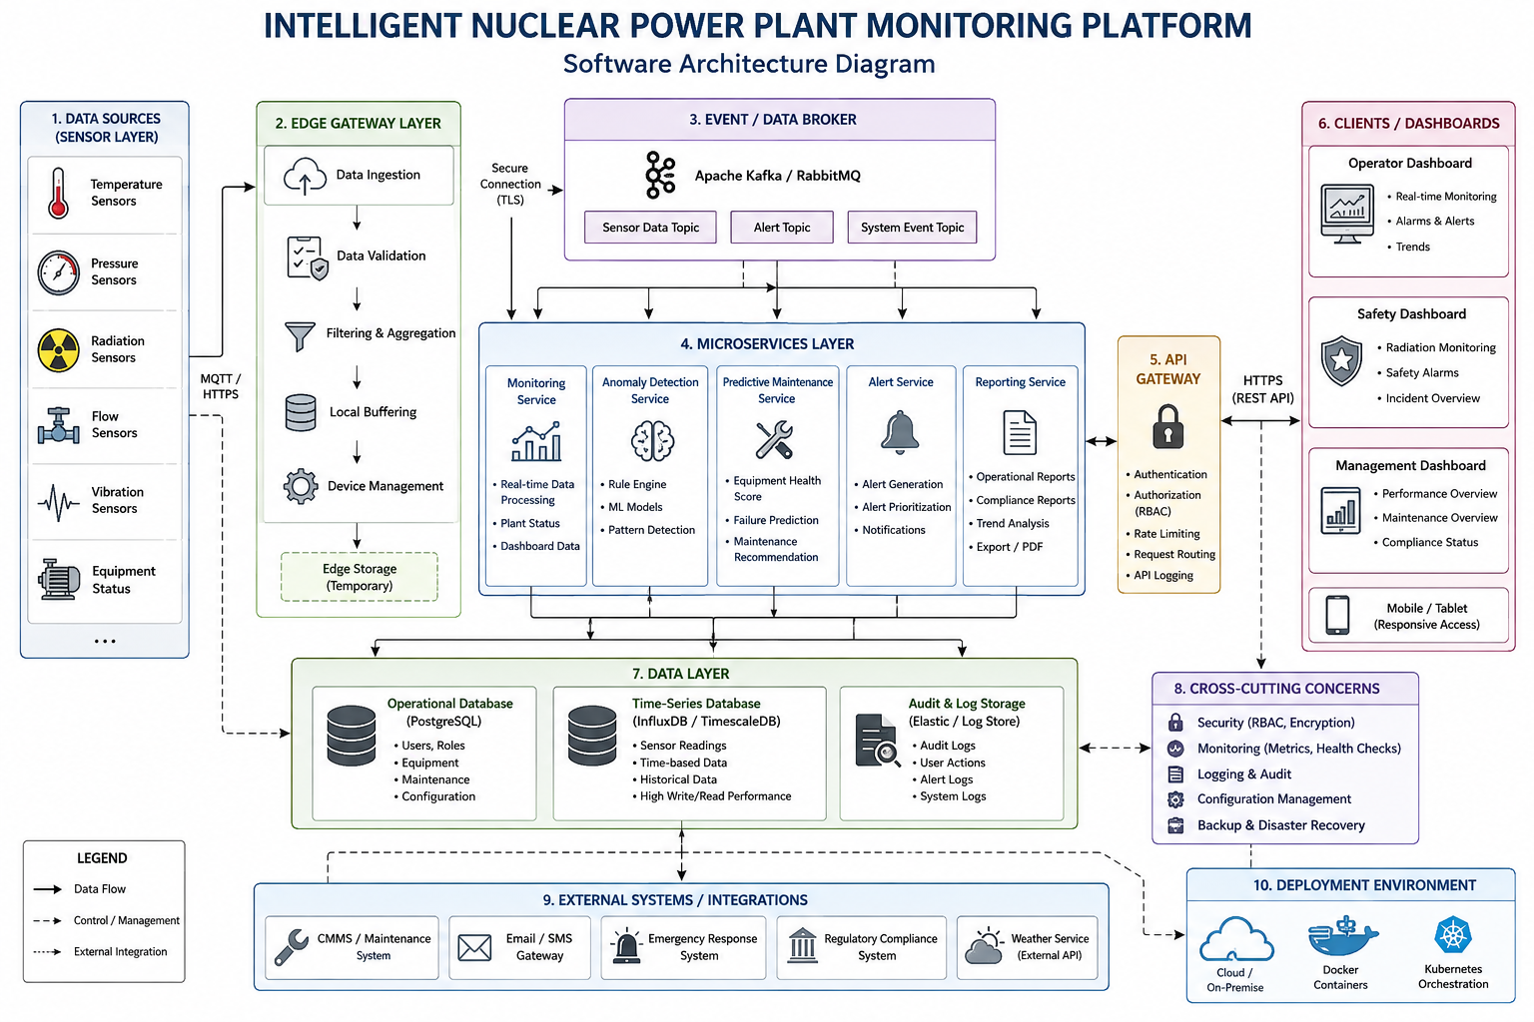

6. Major Architectural Components
6.1 Plant Sensor Layer
This layer contains sensors that collect operational measurements such as:
- Temperature
- Pressure
- Radiation
- Vibration
- Coolant flow
- Equipment status
The sensor layer sends measurements to the edge gateway.
6.2 Edge Gateway
The edge gateway:
- Receives sensor data.
- Performs validation.
- Filters unnecessary data.
- Temporarily buffers data during network problems.
- Sends processed data to the central platform.
Edge processing reduces unnecessary network traffic and can improve response time.
6.3 Event/Data Broker
The event broker distributes sensor and alert events to appropriate services.
For example:
Temperature Event
↓
Event Broker
├── Monitoring Service
├── Anomaly Detection
└── Data Storage
6.4 Monitoring Service
This service processes operational data and provides current plant status to authorized users.
6.5 Anomaly Detection Service
This service analyzes sensor readings and identifies unusual patterns.
Example:
Normal Temperature Pattern
↓
AI/ML Analysis
↓
Abnormal Pattern?
/ \
Yes No
↓ ↓
Generate Alert Continue
6.6 Predictive Maintenance Service
The service analyzes historical equipment data to identify possible future failures.
It can produce:
- Equipment health score
- Failure probability
- Maintenance recommendation
- Historical trend
6.7 Alert Service
The alert service generates notifications for authorized users when predefined thresholds or analytical conditions are reached.
Alert levels can include:
- Information
- Warning
- Critical
- Emergency
6.8 API Gateway
The API Gateway provides a controlled entry point for application clients.
Responsibilities include:
- Authentication
- Authorization
- Request routing
- Rate limiting
- API logging
6.9 Dashboard
Different users receive different dashboards.
Operator Dashboard
- Reactor status
- Sensor values
- Alerts
- Equipment status
Safety Dashboard
- Radiation levels
- Safety alerts
- Incident information
Management Dashboard
- Performance trends
- Maintenance information
- Compliance reports
6.10 Database Layer
The system can use different storage mechanisms according to data type.
Operational Database
Stores:
- Users
- Equipment
- Maintenance records
- Configuration
Time-Series Database
Stores:
- Sensor readings
- Temperature history
- Pressure history
- Radiation measurements
Audit Storage
Stores:
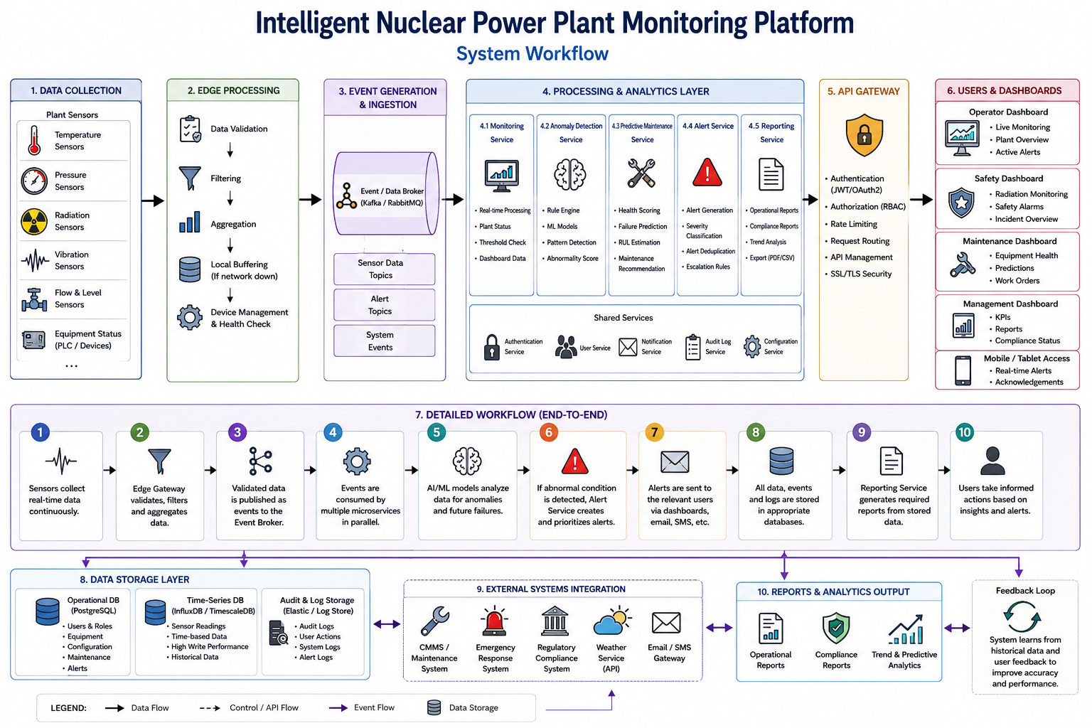
- Login events
- Configuration changes
- User actions
- Alert acknowledgements

7. Component Interaction and Workflow
Step 1: Sensor Collection
Sensors continuously collect plant measurements.
Step 2: Data Validation
The edge gateway validates and filters incoming readings.
Step 3: Event Generation
Validated measurements are published as events.
Step 4: Parallel Processing

Step 5: Historical Storage
Sensor information is stored for trend analysis and future predictive models.
Step 6: AI Analysis
The anomaly and predictive-maintenance services analyze appropriate datasets.
Step 7: Notification
If an important condition is detected, the alert service notifies authorized users.
Step 8: Reporting
Authorized personnel can generate operational and compliance reports.

8. Quality Attribute Analysis
8.1 Scalability
Microservices can be independently scaled.
For example, if sensor data processing increases:
Sensor Data
↓
Monitoring Service × 3
Anomaly Service × 2
Reporting Service × 1
Only the services requiring additional resources need to be scaled.
8.2 Security
Security mechanisms include:
- Role-Based Access Control
- Strong authentication
- Encryption
- Secure APIs
- Network segmentation
- Audit logging
- Least-privilege access
8.3 Performance
Performance is improved through:
- Edge processing
- Event-driven communication
- Asynchronous processing
- Efficient time-series storage
- Caching where appropriate
8.4 Reliability
Reliability is achieved using:
- Service redundancy
- Health monitoring
- Automatic restart
- Data buffering
- Database backup
- Fault isolation
8.5 Maintainability
Each service has a clearly defined responsibility.
For example:
Monitoring Service → Monitoring
Alert Service → Alerts
Report Service → Reports
User Service → Authentication
Changes to one service can therefore be tested independently.
8.6 Availability
The system is designed for continuous monitoring through:
- Redundant services
- Backup databases
- Health checks
- Failover mechanisms
- Persistent event storage

9. Architectural Decisions and Trade-offs
Decision 1: Microservices
Advantages
- Independent development
- Independent deployment
- Better scalability
- Fault isolation
Disadvantages
- More complex deployment
- Network communication overhead
- Requires service monitoring

Decision 2: Event-Driven Architecture
Advantages
- Suitable for continuous sensor streams
- Supports asynchronous processing
- Components are loosely coupled
Disadvantages
- More difficult debugging
- Requires event management infrastructure
- Event ordering and duplicate handling must be addressed

Decision 3: Hybrid Architecture
A hybrid design is selected instead of relying exclusively on microservices because some components can remain logically layered while high-volume processing uses event-driven services.
This provides a balance between:
- Performance
- Maintainability
- Scalability
- Complexity

10. Future Enhancement
Future versions can include:
- Digital Twin integration.
- Advanced AI/ML models.
- Edge AI processing.
- Mobile monitoring application.
- Advanced predictive analytics.
- Automated compliance dashboards.
- Integration with enterprise maintenance systems.
- Advanced observability and monitoring.
- Multi-plant analytics.
- Explainable AI for decision support.

11. Conclusion
The Hybrid Event-Driven Microservices Architecture is appropriate for the Intelligent Nuclear Power Plant Monitoring Platform because the system must process continuous sensor data, support real-time monitoring, provide independent analytical services, maintain strong security, and remain available continuously.
The architecture separates major responsibilities while allowing components to communicate through well-defined APIs and events. It provides scalability, reliability, maintainability, security, and future extensibility while avoiding direct automated control of safety-critical plant functions.

